# Master Rule Guide

PAWN: CAN ONLY MOVE WHEN IT MAKES ITS FIRST MOVE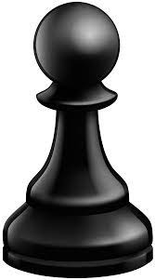

AND THEN IT CAN MOVE 2 TIMES

CAN ONLY GO FOWARD AND CAPTURE ON THE SLANT

KNIGHT: MOVES IN A L SHAPE; 2 UP 1 LEFT

OR RIGHT-OR-1 UP 2 LEFT OR RIGHT. CAN

ONLY CAPTURE WHILE JUMPING IF LANDS

ON SQUARE WITH ENEMY

BISHOP: MAY ONLY MOVE DIAGNOLLY

AND CAN MOVE AS FAR AS ITS LINE OF SIGHT

ROOK: MAY ONLY MOVE STRAIGHT AND CAN

MOVE AS FAR AS ITS LINE OF SIGHT BE ITS LINE OF SIGHT

BE IT FORWARD/ BACKWARD. LEFT/RIGHT

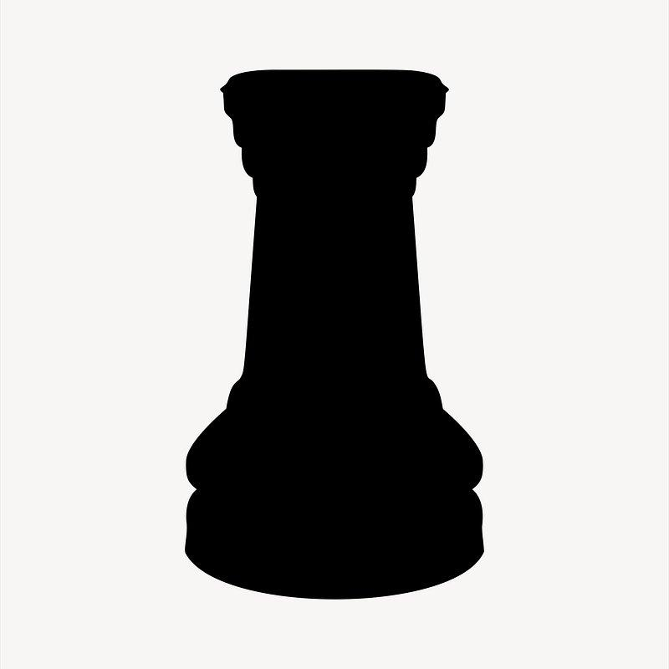

KING: RESTRICTED TO ONE MOVE PER TURN CAN MOVE IN ANY DIRECTION

STRAIGHTS OR DIAGNOLS

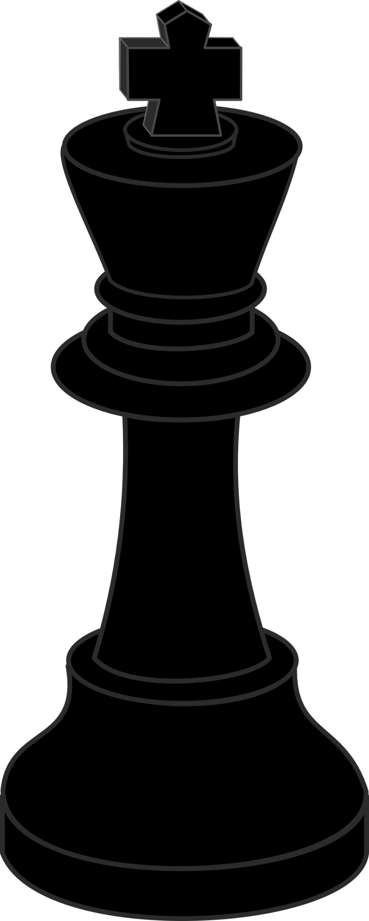

* Footnote for caputiring
* All pieces except for the pawn caputure by moving normally and langing on top of an opponent’s piece
* Pawn
* When a piece is one square ahead of and one square to either side of the pawn, the pawn may move diagonally to where the peice is and caputure
* Special moves
* En peasant
* When a black pawn is on the 4th rank or a white pawn is on the 5th, and the opponent moves their pawn 2 squares to be next to player’s, the player may capture normally by moving diagonally one square.
* Castling
* If neither the king nor the castling rook have moved during the game, and there are no pieces between them, the player may move the king two pieces towards the rook and move the rook to the opposite side of the king.
* How to win
* Check: Check means when a king is under attack by one or more enemy piece. In this scenario, the player in check must either:
* Move the King to a square where it is no longer in check
* Capture the attacking piece whether with the king or other pieces.
* Block the check by putting a game piece between the king and the attacker.
* Putting oneself’s king in a check position is illegal. It is also illegal to leave your king in a checked position.
* If it is not possible for a king to get out of check using the above mentioned rules, the player is in Checkmate( see next section)
* Checkmate
* When the king is in checkmate, the game ends and the checkmated player has lost. To achieve checkmate, the checkmated player is in check from the opponent and has no legal moves to Move the king, Capture the attacker or Block the check.
* Other circumstances
* Draws
* Stalemate- A player has no legal moves and the player is not in check.
* By repetition- If the same position is reached 3 times, the game ends in a draw.
* Insufficient Material- This occurs when there is no way for either player to achieve checkmate with the pieces on the board. See table for all possible draw by insufficient material.
* 50 move rules: If 50 moves have passed since last pawn move or capture, the game ends in a draw regardless of king movement.
* Forfeit : A game can be forfeited by any player at any time. If a player forfeits, the game is over and the player loses.
* Strategy
* Project the king
* Protect the king by ensuring there are no easy ways to check him. A common strategy is to move the king-side bishop and knight, then castling on the king side, and pushing either the 1st or 8th rank pawn, depending on which side the king is on.
* How many points a piece is worth
* When playing chess, it is helpful to assign point values to pieces to help decide which pieces are more important during a game
* Pawn: 1
* Knight: 3
* Biship: 3
* Rook: 5
* Queen: 9
* King: No point value/ ultimate piece
* Optional Conditions
* Clock
* During a game, players can use a clock time each player. When the game starts, the clock counts down from the given time limit for whichever player’s turn it is. When that player has moved, they press the clock and start the countdown for their opponent. If the clock runs down to 0 for a player, that player loses.

[How to Play Chess: Learn the Rules &](https://www.chess.com/learn-how-to-play-chess)